*Use the information in Chapter 43 (p.929-950) to complete the following questions. Bozeman’s podcast the* [*Immune System*](http://www.bozemanscience.com/immune-system) *may also be helpful to view prior to doing the reading.*

**Concept 43.1 In innate immunity, recognition and response rely on traits common to groups of pathogens**

Contrast the types of innate responses found in both invertebrates and vertebrates.

|  |  |  |
| --- | --- | --- |
|  | Invertebrates (insects) | Vertebrates (mammals) |
| Barrier defense |  |  |
| Phagocytosis |  |  |
| Antimicrobial peptides |  |  |
| Inflammatory response | ----------------------------------------------- |  |

**Concept 43.2 In adaptive immunity, receptors provide pathogen-specific recognition**

Discuss the source and relevance of antigens and lymphocytes in activating an adaptive immune response in vertebrate animals.

Use Figure 43.10 (p.936) to explain how antigens are recognized by B cells and antibodies.

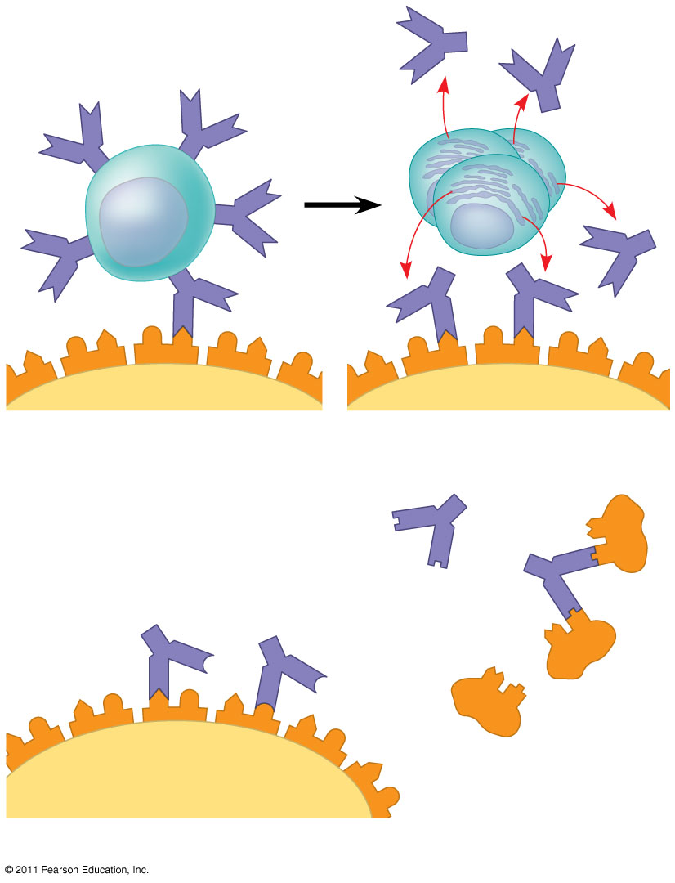

Use Figure 43.12 (p.937) to explain how antigens are recognized by T cells.

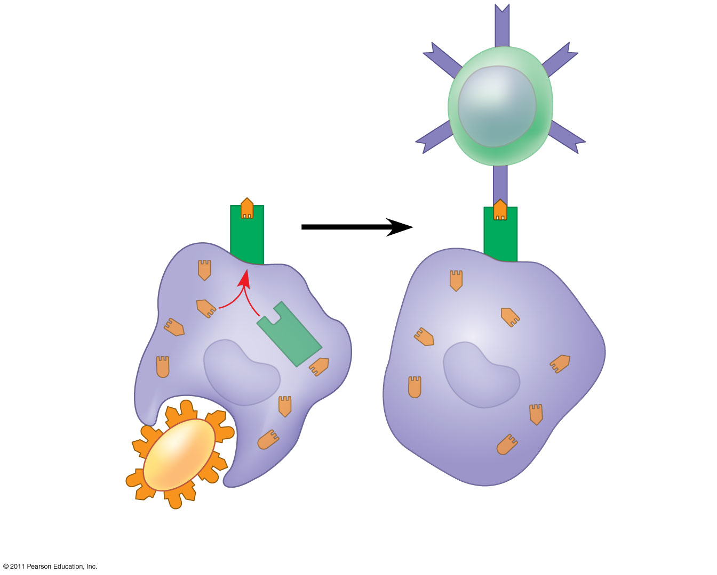

Contrast the primary and secondary immune response to a specific pathogen.



**Concept 43.3 Adaptive immunity defends against infection of bodily fluids and body cells**

Use Figure 43.16 (p.941) to explain the role of helper T cells in humoral and cell-mediated immune responses.

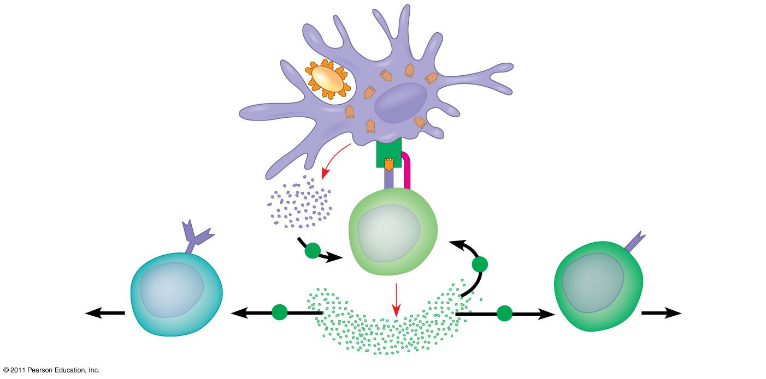

Use Figure 43.17 (p.941) to explain how a cytotoxic T cell kills an infected host cell in the cell-mediated immune response.

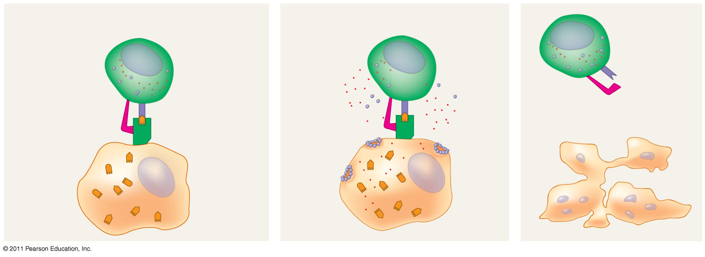

Use Figure 43.18 (p.942) to explain how activation of a B cell results in the humoral immune response.

